Khan Academy CS Unit Review Game

# Section 1: Drawing with Variables (2 points per problem)

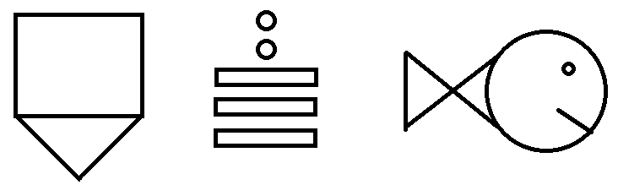

# Section 2: Functions (2 points per problem)

1. Take one of the drawing from section 1 and put it in a function. Call the function twice, each time displaying the drawing in a new section of the screen. Hint: remember how we decorated our Christmas trees.
2. Take another one of the drawings from section 1 and put it in a function. Call function four times, each time placing a new drawing in a different corner of the screen.

# Section 3: Animating and If Statements (3 points per problem)

1. Take one of the drawings from section 1 and have it bounce off of the walls with exact precision. That is, the shape should bounce at the exact moment that one of its edges touches the wall.
2. Take one of the drawings from section 1 and animated it in the x direction only. When it crosses the right edge of the screen, have jump to the middle of the scree then move leftwards. When it crosses the left edge of the screen, have it jump to the middle of the screen then move rightwards.
3. Use the function from section 2 to animate two of the same drawing moving across the screen in unison.